
DEPARTMENT OF

COMPUTER

Experiment 2
Student Name:Riya Kashyap UID: 25MCA20033
Branch: MCA-UIC Section/Group: 1
Semester: 2nd Date of Performance:13/1/2026
Subject Name: Technical Training Subject Code: 25CAP-652

- Aim:The aim of this project is to create and manage an orders database using SQL and to perform various database operations such as inserting data, retrieving records, sorting results, grouping data, and applying aggregate and conditional functions to analyze sales information effectively.
- Objective:The objective of this project is to gain practical knowledge of SQL by creating a table, inserting records, and executing queries using WHERE, ORDER BY, GROUP BY, HAVING, aggregate functions, and CASE statements to generate meaningful summaries and insights from the stored data.
- Practical/Experiment Steps:
- Design an orders table with appropriate attributes
- Create the table using SQL commands
- Insert multiple records into the table
- Retrieve records based on conditions
- Sort the retrieved data in descending order
- Group data and calculate total sales
- Apply aggregate and conditional functions for analysis

- Procedure of the Practical:

CREATE TABLE orders (
order_id INT,
customer_name VARCHAR(50),
product VARCHAR(50),
quantity INT,
price NUMERIC(8,2),
order_date DATE
);

INSERT INTO orders VALUES
(1, 'Amit', 'Laptop', 1, 55000, '2024-01-10'),
(2, 'Riya', 'Mobile', 2, 22000, '2024-01-12'),
(3, 'Rahul', 'Laptop', 1, 60000, '2024-01-15'),
(4, 'Sneha', 'Tablet', 3, 15000, '2024-01-18'),
(5, 'Ankit', 'Mobile', 1, 25000, '2024-01-20'),
(6, 'Pooja', 'Laptop', 2, 58000, '2024-01-22'),
(7, 'Karan', 'Tablet', 1, 18000, '2024-01-25');

SELECT customer_name, product, price
FROM orders
WHERE price > 20000;

SELECT customer_name, product, price
FROM orders
ORDER BY price DESC;

SELECT product,
SUM(quantity * price) AS total_sales,
COUNT(*) AS total_orders
FROM orders
GROUP BY product;

SELECT product,
SUM(quantity * price) AS total_sales
FROM orders
GROUP BY product
HAVING SUM(quantity * price) > 50000
ORDER BY total_sales DESC;

SELECT product,
SUM(CASE
WHEN price > 20000
THEN quantity * price
ELSE 0
END) AS high_value_sales
FROM orders
GROUP BY product
ORDER BY high_value_sales DESC;

- Output:

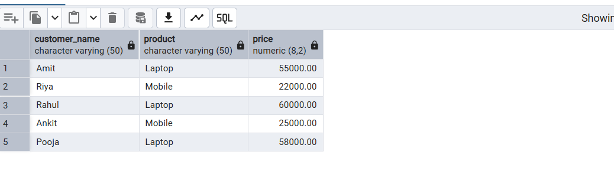

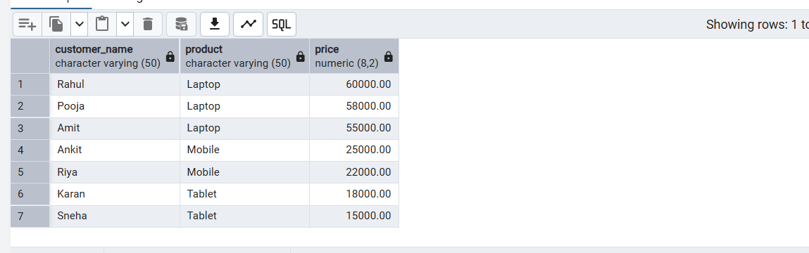

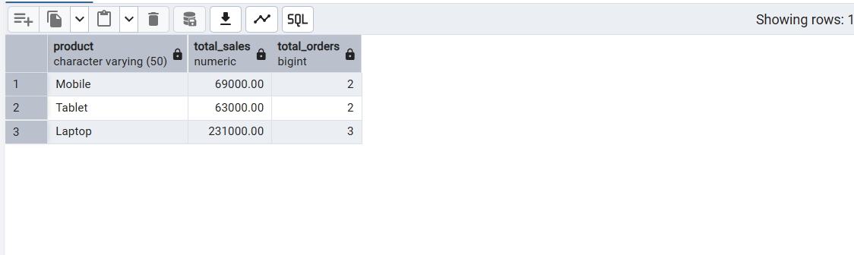

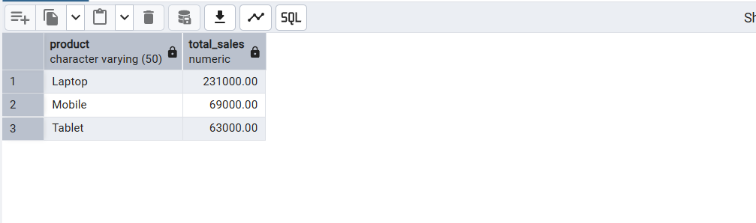

- Learning Outcome:
- Understood the concept of relational database tables and data types.
- Learned to create tables and insert records using SQL commands.
- Gained knowledge of data retrieval using SELECT and WHERE clauses.
- Learned how to sort data using the ORDER BY clause.
- Understood the use of aggregate functions such as SUM() and COUNT().
- Learned to group data using the GROUP BY clause.
- Understood the difference between WHERE and HAVING clauses.
- Gained practical experience in using CASE statements for conditional data analysis.

